  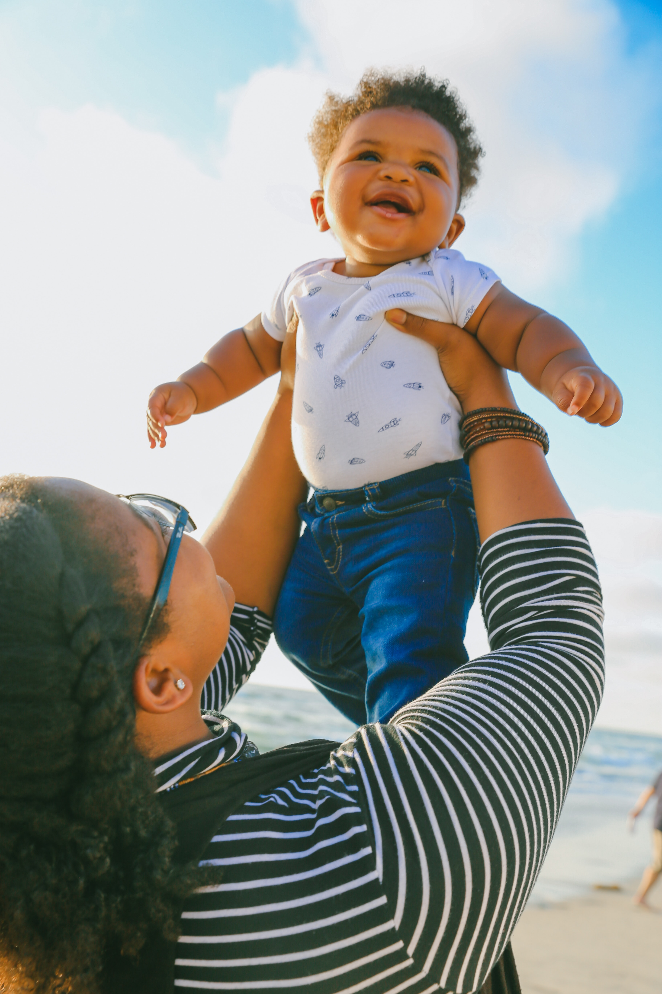
  Baby Love Parenting Program
  Baby Love is a FREE group-based attachment-based program for babies ages 2-16 months and their caregivers. Together, we will talk about:
  - the importance of attachment
  - ways to make your baby feel secure
  - ways to help your baby deal with stress
  Sessions include activities for babies & caregivers, practice sessions and Q&A.
  Developed and supported by Dr. Wittenberg (SickKids).
  
  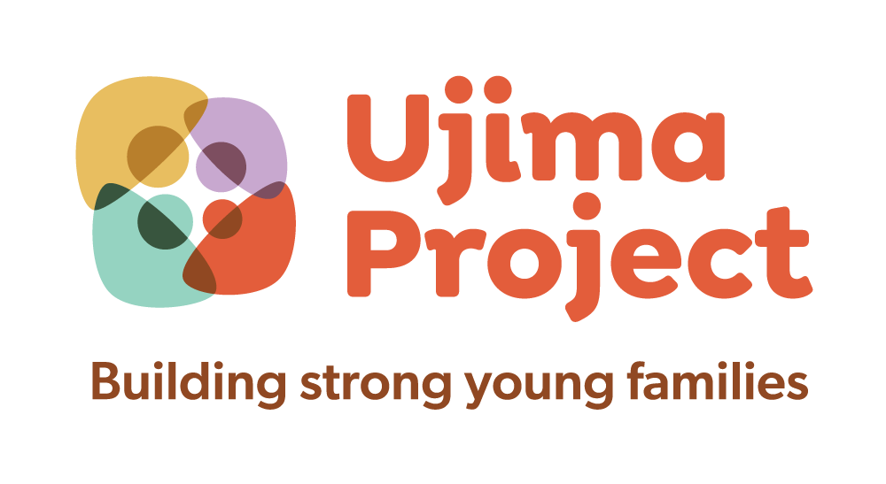
  when:
  THURSDAYs FROM SEPT. 22-Nov. 3 2022 2:30-4:30 pm
  D
  Y
  TI
  where: 1475 Barton St. E
  HAMILton, on
  Cost: Free!
  ada
  Light refreshments and weekly prizes
  contact:
  Michelle Woods
  Mwoods@gsch.cao
  289-659-5671
  For more info about Ujima Project: https://www.oaypa.ca/ujima-project

