Name____________________________________

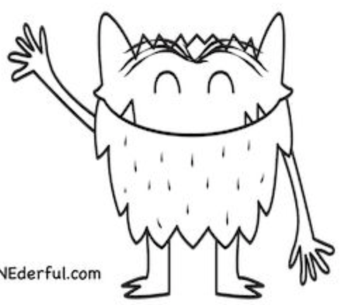

I feel ____________________________.

