Penny & Katy Present:
This Photo by Unknown Author is licensed under CC BY
Life Skill/Leisure Theme for Week of April 20-24th
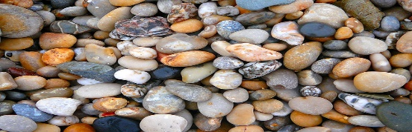
“Stones & Rocks”
This Photo by Unknown Author is licensed under CC BY

Here are some ideas to provide leisure activities relating to stones/rocks for your child. Please take the opportunity to try all the activities or only the ones you feel are meaningful for your child.

- Listen to/watch the story: Emma’s Gems (link below)
https://www.youtube.com/watch?v=_7IduRE2gCQ
Following the story, you may wish to explore the sounds of coins jingling and the feel of stones or rocks and ask if your child likes the sound of the coins or the feel of the stones. If your child is non-verbal you may want to look for the gestures that indicate a “yes” or a “no”.
You can discuss with your child:
- how they could share with someone (sharing toys, a chore, food or turns during a game)
- how they could help an animal (caring for a pet, feeding the birds)
- how they can help take care of the environment (picking up litter in the yard or while on a neighbourhood walk, recycling)


- Listen to/watch the song: Stone Soup (link below)
https://www.youtube.com/watch?v=LCqbqyT62e8
Does your child seem engaged during the song? (watching, smiling, clapping, change in body position)
- Creating with Stones:
If possible, have your child collect stones or rocks from your yard or neighbourhood. In order to prepare your stones, have your child give them a bath in small tub with dish soap and water. They can use a scrub brush to scrub them clean. This is a great way to have some sensory time in warm, bubbly water. Don’t forget to towel them dry.
There are a variety of creative activities that can be done with stones or rocks:
- Painting stones/rocks
- Colouring stones/rocks with markers
- Bedazzling stones or rocks
- Tracing stones/rocks
- Making sculptures of stones or rocks

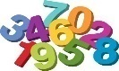
This Photo by Unknown Author is licensed under CC BY-NC-ND
- Extension Numeracy Activities for Stones/Rocks
If appropriate for your child, you may wish to have them complete some numeracy activities with a collection of stones/rocks.
- Count the collection of stones/rocks
- Sort the stones according to size (small, big)
- Count the stones in each pile
- Make a pattern with the stones/rocks (small, large, small, large, etc.)

Click link below to see a video of some of the above ideas:
https://tv.commons.hwdsb.on.ca/media/stone-rock-activities/

**If your child doesn’t have access to stones/rocks, you could cut out pieces of paper to resemble stones and rocks and then use these for the numeracy activities.
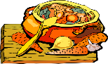
This Photo by Unknown Author is licensed under CC BY-NC
Making Stone Soup:
You may wish to have your child help in making your family’s favourite soup or use one of the links below for a recipe for “Stone Soup”. With your assistance and supervision, your child may be able to help with the following:
- Peeling or chopping vegetables
- Adding items to the pot before it’s placed on the stove
- Adding cups of water/stock to the pot before it’s placed on the stove. Try counting the number of cups that are poured.
- Stirring the pot before its placed on the stove. Try counting as you stir.
Below are links for a Stone Soup video and a recipe:
https://www.youtube.com/watch?v=X-Nn5tbp1uA
https://www.food.com/recipe/ol-fashioned-stone-soup-213767
Hope you enjoy these activities!
In order to help us determine what is working well for students, please consider the following questions:
- Was your child engaged with all the activities, just some or none. Which were most engaging for your child?
- Did your child self-regulate (demonstrate appropriate behaviour) during all the activities, just some or none?
If possible, please mention the answers to these questions to your child’s teacher the next time you have a conversation either through email or over the phone. Your feedback can assist us in planning more meaningful activities.
If you have any questions about these activities,
please contact Katy at kgurman@hwsdb.on.ca or Penny at pparry@hwdsb.on.ca
Thanks and be well! 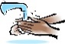
This Photo by Unknown Author is licensed under CC BY-SA
Penny & Katy

